**Part A: System Documentation**

**1. Requirements Elicitation**

**Objective:** Elicit and specify the system's requirements to create a solid foundation for development.

Based on the conducted interview with the client (Mr. Themba Moeng), the following requirements for the Banking System have been identified.

**1.1. Functional Requirements [5 marks]**

Functional requirements define what the system must do. The core functions of the Banking System are as follows:

* **Customer Management:**
  + The system shall allow the creation of two types of customers: **Individual** and **Company**.
  + For an **Individual Customer**, the system must collect: National ID/Omang number, first name, surname, date of birth, contact number, email, and residential address.
  + For a **Company Customer**, the system must collect: Company Registration Number, company name, primary contact person, company address, and contact details.
  + A customer can hold one or more accounts of any type (e.g., a customer can have a Savings, an Investment, and a Cheque account simultaneously).
* **Account Management:**
  + The system shall support three types of accounts: **Savings**, **Investment**, and **Cheque**.
  + The system shall automatically generate a unique account number for each new account.
  + The system shall allow a bank employee to open a new account for a new or existing customer.
  + **Savings Account:** Allows deposits but **does not allow withdrawals** except upon account closure. It earns a monthly interest of **0.05%** on the balance.
  + **Investment Account:** Requires a **minimum opening and maintained balance of BWP 500.00**. Allows both deposits and withdrawals (provided the minimum balance is maintained). It earns a monthly interest of **5%** on the balance.
  + **Cheque Account:** Can be opened for individuals or companies. For individuals, it requires proof of employment (employer details must be stored). Allows unlimited deposits and withdrawals. **Does not allow overdrafts/negative balances** and **does not earn interest**.
* **Transaction Processing:**
  + The system shall allow deposits to be made into any active account.
  + The system shall allow withdrawals from Investment and Cheque accounts, subject to their specific business rules (e.g., minimum balance).
  + Every transaction (deposit/withdrawal) must be logged with details including: transaction type, amount, timestamp, and the involved account number.
* **Interest Calculation and Payment:**
  + The system shall have a function to apply monthly interest to all eligible accounts (Savings and Investment).
  + Interest must be calculated and applied to an account's balance **regardless of the account's age** (i.e., no pro-rating for accounts not a full month old). The process can be initiated manually by a user (e.g., a manager).
* **Data Persistence and History:**
  + All customer information, account details, and transaction histories must be stored permanently in a database.
  + Transaction history for an account must be maintained **indefinitely** and must be fully accessible whenever the account is viewed.

**1.2. Non-Functional Requirements: [5 marks]**

Non-functional requirements define how the system should perform its functions.

* **Security:**
  + The system must ensure data integrity and prevent unauthorized access. This will be achieved through user authentication (login for bank employees).
  + All sensitive customer data (e.g., ID numbers, balances) must be protected.
* **Usability:**
  + The user interface (used by bank tellers and managers) must be intuitive, user-friendly, and efficient to use, requiring minimal clicks to perform common tasks like deposits or withdrawals.
* **Reliability & Performance:**
  + The system must be highly available during banking hours.
  + It must reliably store all transaction data without loss.
  + Core operations like depositing funds must process quickly.
* **Maintainability:**
  + The code must be well-structured using Object-Oriented Principles (abstraction, inheritance, polymorphism, encapsulation) to allow for easy future expansion, such as adding new account types.
* **Data Integrity:**
  + The system must enforce all business rules (e.g., no withdrawals from Savings, minimum balance on Investment) to ensure the integrity of financial data is never compromised

See appendix A for Mock interview

UML diagram modelling for the Banking system.

Note: The Visual paradigm project files have been uploaded in the same folder (.docs) as this word document (Part A _RE & UML modelling) to aid in viewing of the diagrams.  
  
Structural modelling  
  
-class Diagram

-Use case Diagram

Behavioural modelling

-sequence diagrams

A-withdrawal from a cheque account.

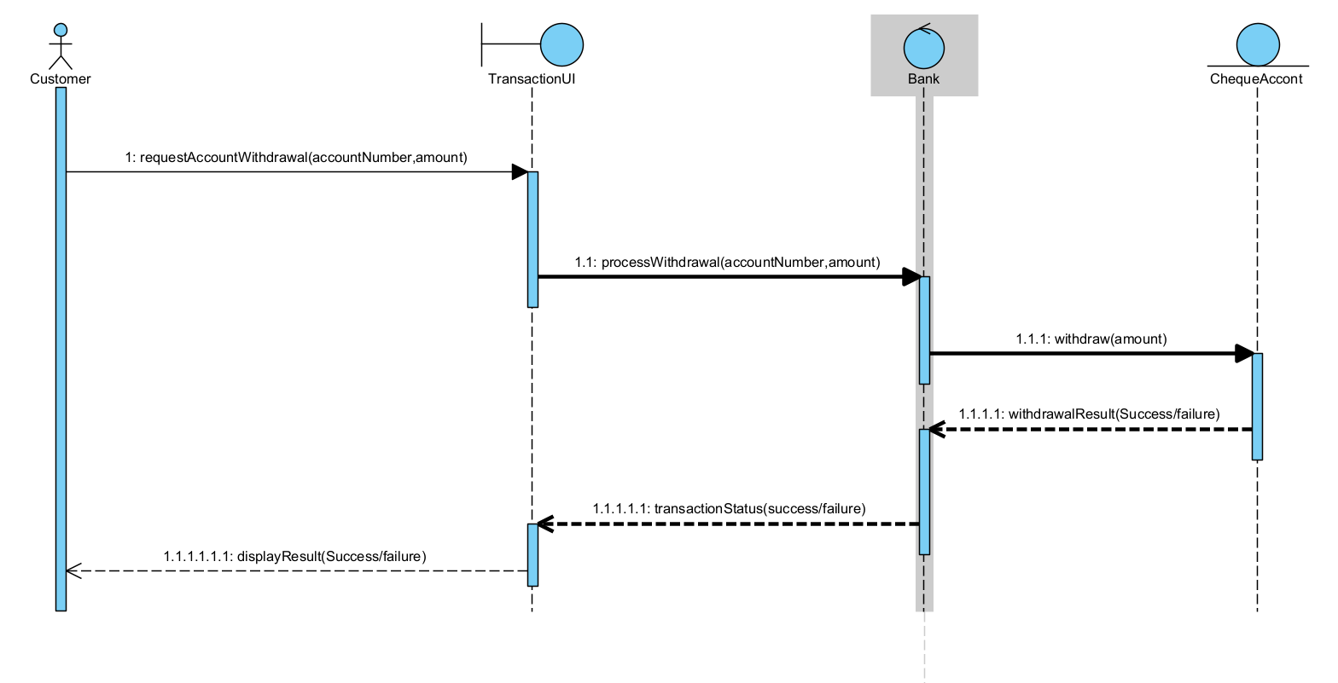

B- Account creation

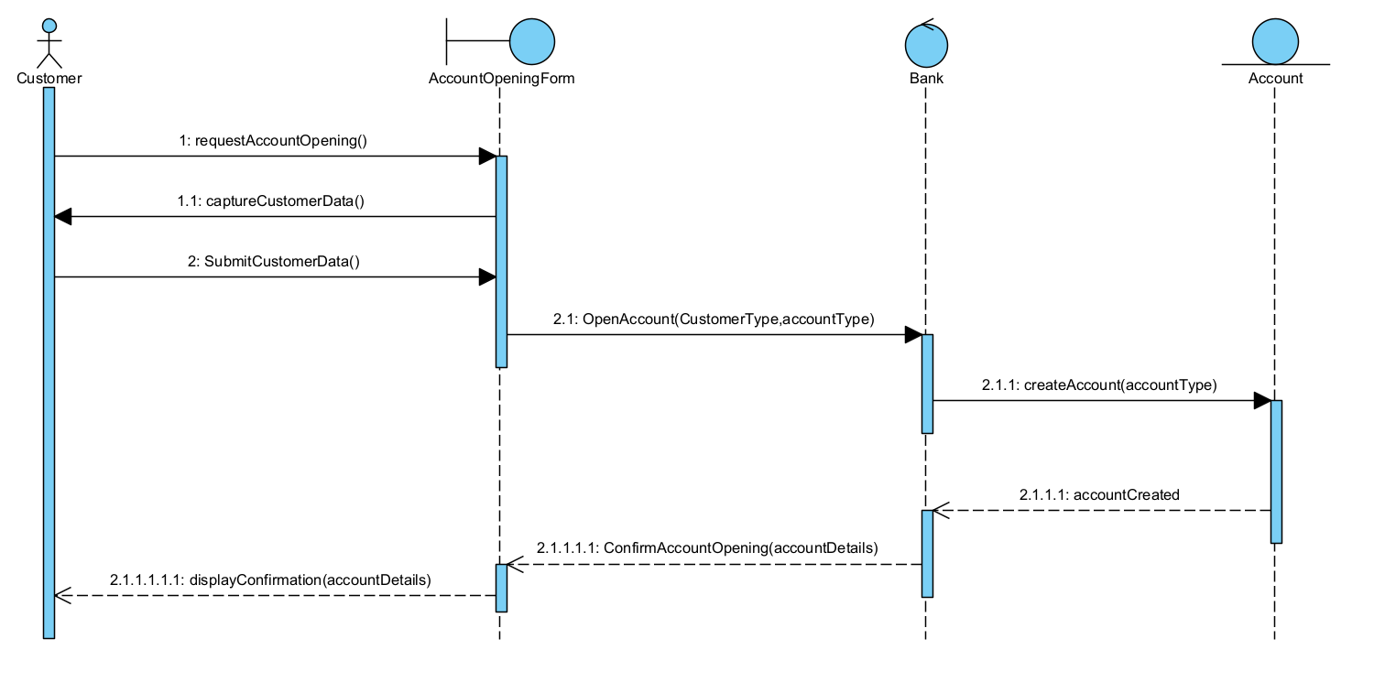

state diagram

withdrawal from cheque account

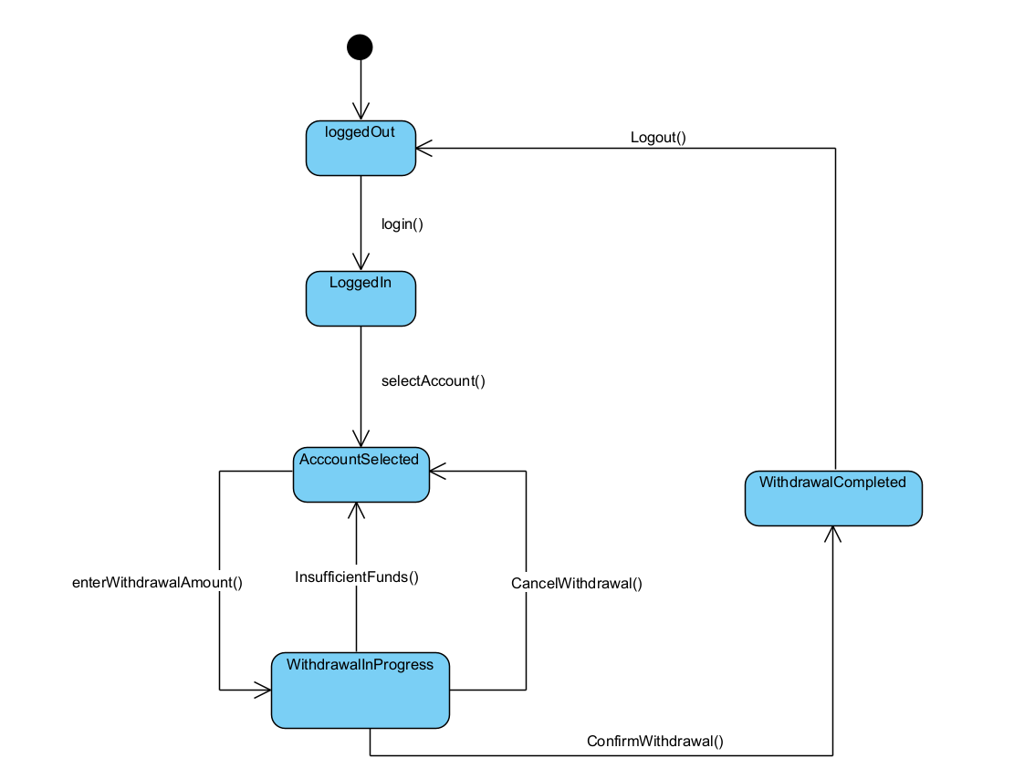

Appendix A

Interview Record – Banking System Requirements

Date: 8:14-8:23

Time: 8:14-8:23

Place: Virtual meeting (Microsoft Teams)

Participants:

- Interviewer: Larona O Mothame (Student)

- Interviewee: Themba Moeng (Tutor / Acting as Client)

# Objective

The purpose of this interview was to elicit requirements for the Banking System project. The focus was on clarifying the entities (Customer, Account), the business rules for account types, system functionality, and non-functional requirements.

# Section 1: Customer Entity

Q1: For an individual customer, what specific information must we collect?

A1: National ID/Omang number, date of birth, contact number, email, residential address

Q2: For a company/organization customer, what details do we need?

A2: Company Registration Number, primary contact person, company address, contact details

Q3: Should the system differentiate between individual and company customers in terms of workflow and validations?

A3: Not necessarily only in the sense of the information collected about the two types of customers.

# Section 2: Account Entity

Q1: Should the account number be generated and encode some information like branch code or should it just be a simple one, for example account number -001?

A1: Yes, generating the account number will help you out a lot when creating accounts

# Section 3: Account Types & Business Rules

Q1 (Savings Account): Withdrawals are not allowed — is this absolute or are there any exceptions?

A1: Yes, the customer can only access their funds upon closure of account. But in terms of the other aspects like deposits they are fully functional.

Q2 (Investment Account): The BWP 500 deposit — is it a minimum balance or just an opening requirement?

A2: Yes, the P500 is the minimum balance and is to be maintained throughout the life of the account. The only exception is on account closure.

Q3 (Investment Account): The 5% monthly interest seems high — is this correct, or should it be per annum?

A3: Yes, it is correct cause this is an academic project so don’t worry much the interest rates

Q4 (Cheque Account): Are cheque accounts strictly for individuals, or could companies also have them?

A4: No, a company can also have a cheque account.

Q5: The interest of the accounts – is it calculated at the end of every month and if so how is the interest of accounts that are not month old treated?

A5: for simplicity sake we are going to calculate the interest of every account because what we're looking for is for consistency we want to be able to press a button and the system should be able to go through the accounts and apply the appropriate interest for the appropriate account. Right because imagine if now we would have to wait a month for you to for the system to allocate interest and then we would come back and show that it is able to do that so yes. The interest would be allocated regardless that the account may be 15 days old or less than a month old

Q6: Should the accounts allow negative balances?

A6: no the account should not allow you to overdraft

# Section 4: System Functionality & User Interaction

Q1: Who are the users of this system (tellers only, or also customers via a portal)?

A1: The bank employees i.e. The bank tellers and manager and the customer.

Q2: For transactions, what details should be logged?

A2: yes, details that should be logged should be the type of transaction as in deposit or withdrawal and the time the account that made that transaction and the amount in which the transaction was made

Q3: Should transaction history be maintained indefinitely or only for a limited time?

A3: Yes, the history should be maintained indefinitely such that when you leave the application and come back you should always find them and basically all of the transaction history of that particular account should be accessible.

Q4: How far back should the transaction history go?

A4: all of the transaction history of that particular account should be accessible.

# Conclusion

The interview clarified the requirements for different account types (savings, investment, cheque), customer types (individual vs. company), system processes (opening accounts, transactions, interest payments).